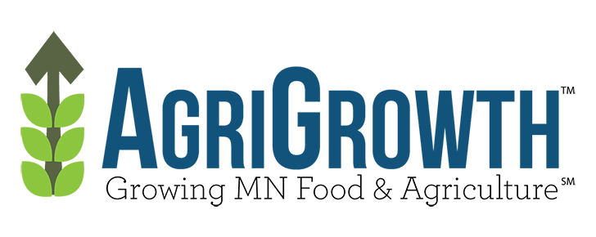As I have traveled across Minnesota in recent months meeting with Minnesota AgriGrowth Council members, I have heard loud and clear that farmers and agribusinesses are counting on this Legislature and Governor Dayton to address the critical need to pass a robust transportation funding package this session.
This is an important issue for Greater Minnesota communities, not only the point of origin for many of our agricultural products, but also the destination for many of the goods that keep our rural areas efficient and productive. Roads and bridges are the first link in our transportation system that connects Minnesota’s agriculture sector to local, national and global markets. Without new investments to maintain and modernize our road and bridge system, Minnesota agriculture and Greater Minnesota risk losing out on future jobs and economic opportunities. Our state’s economy suffers when bridges are posted at lower weight limits, and our local roads are not built to a 10-ton standard.
We expect our state government to support rural jobs by creating the conditions for success, and a major part of that is a well-maintained transportation system, ensuring goods and services can move efficiently inside our state, as well as across borders. Investment in transportation

infrastructure is a key and basic function of our state and local governments, and frankly should not be as controversial as it has sometimes been.
There is a reason why we are so confident that the 2017 Legislature will finally deliver a transportation funding bill. Groups that have sometimes been at odds, or often disagree on priorities are standing together to say that this must be a priority this year and we’re here to help get it done. On top of that, during the 2016 election cycle, legislative candidates from both sides of the aisle campaigned on making transportation investment a priority.
We know that there will also be a robust discussion on exactly what mechanisms are available to fund the significant need. Many ideas have been proposed. We know that, as in most good public policy debates, not everyone is going to get all of what they want. There will be compromise, discussion; give and take.
To protect and grow jobs in Minnesota, new investment in transportation must occur this session. It’s time for action. AgriGrowth and members of the coalition that is advocating for action on transportation funding package this session are ready to help Governor Dayton and legislators fulfill their commitments to voters.
Perry Aasness
Executive Director
Minnesota AgriGrowth Council

