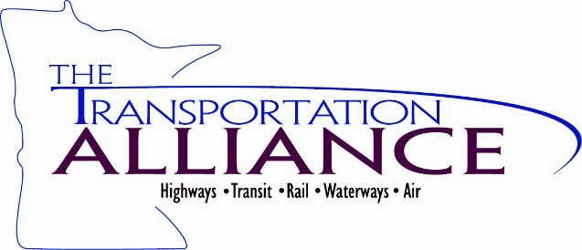

Infrastructure Investment and Jobs Act (IIJA) Workshop
Thursday, December 16th, 2021

Please share any additional feedback you have about the material presented,
about IIJA or about today’s event. Thank you for your participation.
_____________________________________________________________________________________________________________________________________________________________________________________________________________________________________________________________________________________________________________________________________________________________________________________________________________________________________________________________________________________________________________________________________________________________________________________________________________________________________________________________________________________________________________________________________________________________________________________________________________________________________________________________________________________________________________________________________________________________________________________________________________________________________________________________________________________________________________________________________________________

