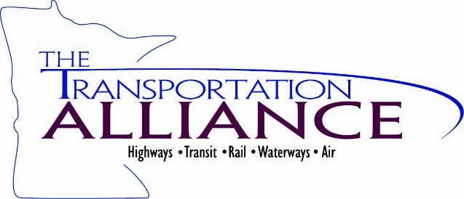

BREAK-OUT SESSIONS

Breakout Session I – 2:15 pm
Breakout Session II – 2:45 pm

Choose one of these topic areas:
Equity – What does equity in a transportation context mean to you?

Grants – Which programs look the most useful to you?

Highway funding – How do you see statewide funding using the additional IIJA money?
- How do you see local funding being used by the additional IIJA money?
- What highway projects would you prioritize with new highway funding?
- What bridge projects would you prioritize with new bridge funding?

Local Gov Funding – What formula program do you think has the most opportunities for local highway projects?

Planning – How do you think IIJA will impact the 20 yr MNSHIP planning process or the 10 yr CHIP?

Safety – How do you see technology impacting highway safety projects?

Transit and Active Transportation – What impact will IIJA have on transit and active transportation planning and project development?

FEEDBACK ON IIJA

Please provide any comments you would like to convey to MnDOT and the Metropolitan Council regarding the use federal funds provided though the IIJA or the impact you would like to see this bill have on the transportation system in Minnesota.

_________________________________________________________________

_________________________________________________________________

_________________________________________________________________

_________________________________________________________________

_________________________________________________________________

__________________________________________________________________

__________________________________________________________________

