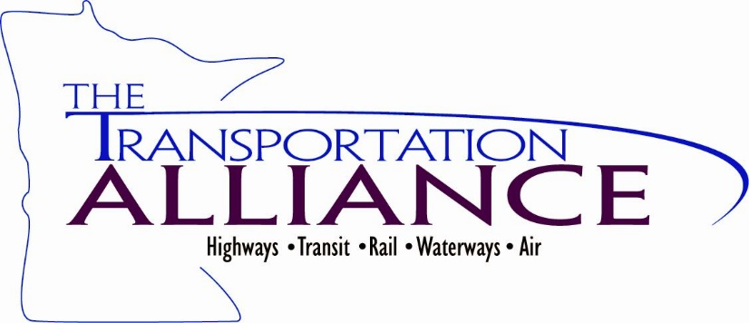
Transportation Talking Points

- Safety on the roadways remains a critical issue. Every year more than 360 Minnesotans are killed on our roadways. Investments in making roads and bridges safer and more effective are needed.

- Local governments struggle to keep up with maintenance costs on the many miles of roadway and many bridges under their jurisdiction. Maintaining existing roadways, improving mobility, replacing structurally deficient bridges and protecting and expanding transit assets that people and businesses rely on every day should be a top priority in 2020.

- Minnesota’s population is growing and generating increasing congestion while our system is aging, giving Minnesota’s infrastructure with an overall grade of C from the American Society of Civil Engineers including grades of D+ for roads and C- for transit.

- Transit systems play a critical role in getting people to work, school, medical appointments and other important destinations and current service levels are not able to keep up with the needs of Minnesota residents.

- Funding for roads, bridges and transit continues to fall behind with an estimated shortfall of over $600 million per year for roads and bridges and over $200 million per year for bus and bus rapid transit service.

- The state has the capacity to pass a significant capital bonding bill. The governor has released his recommendations for a $2.6 billion bonding bill that includes funding for critical transportation programs and projects.

- A strong investment in public infrastructure will create immediate, well-paying jobs and lead to increased economic development, enhancing Minnesota’s economy statewide. Transportation projects are ready to go – awaiting funding.

525 Park St., Ste. 240 Saint Paul, MN 55103 651/659-0804 Fax 651/659-9009
Email: margaret@transportationalliance.com www.transportationalliance.com

